**Procedure for greatest of two numbers:**

create or replace procedure greatest(

n1 int,n2 int,result out int

) as

Begin

If n1>n2 then

Result:=n1;

Else

Result:=n2;

End if;

End;

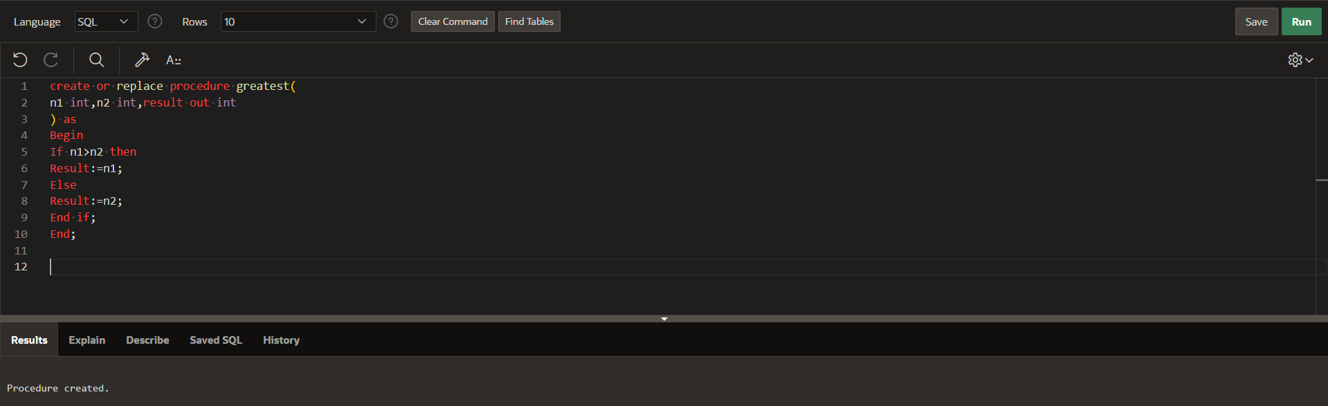

Declare

Result int;

Begin

greatest(10,20,’result’);

Dbms_output.put_line(Result);

End;